Lab: C# and ASP.NET

## Numbers from 1-50

Create an MVC application, which **prints** the numbers from **1** to **50** inside a view.

### Create New Project

Let’s create a new project. Open Visual Studio and click on [File]🡺[New]🡺[Project]:

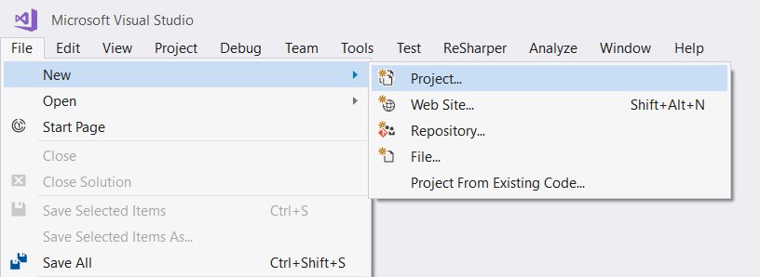

Next, select [C#]🡺[Windows]🡺[Web]:

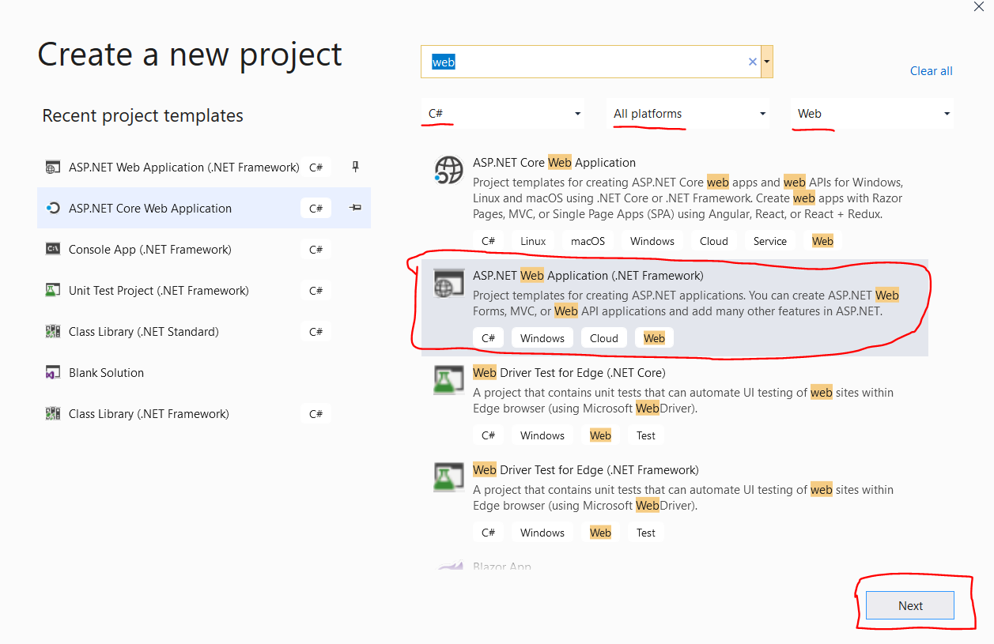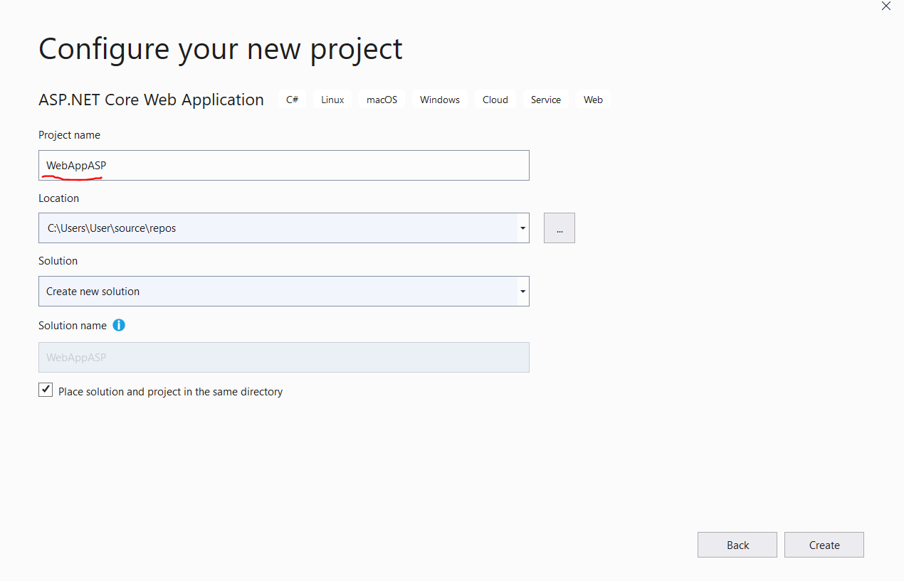

If you don’t have “Web” in the selection, click [Open Visual Studio Installer] and install the “ASP.NET and web development” component:

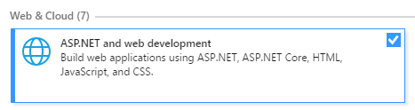

Next, choose the MVC template. After that, make sure to change **authentication type** to “**No authentication**”:

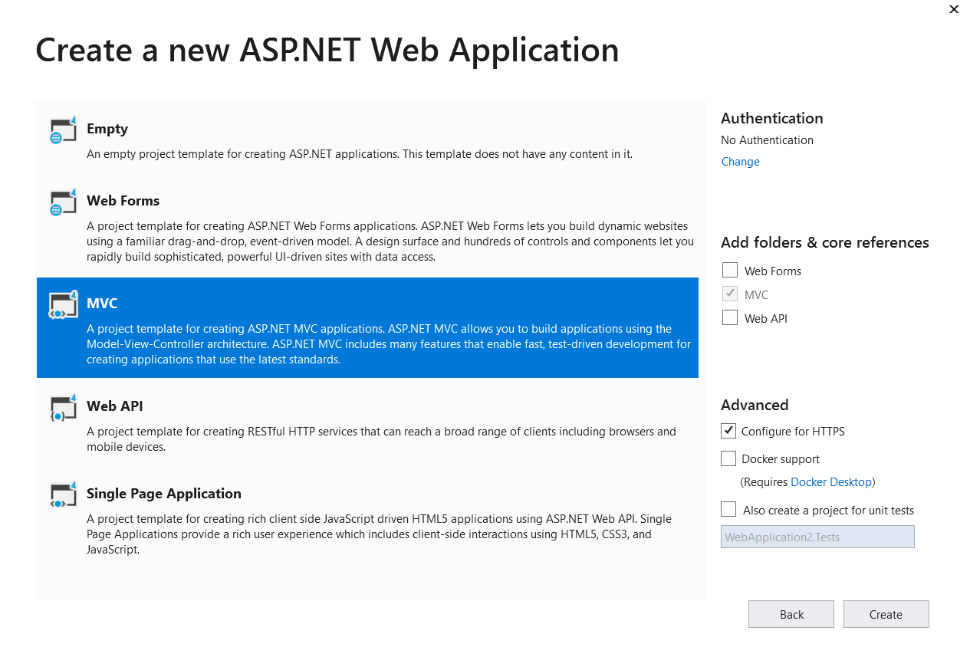

At this point, we should have the project created and in front of us.

### Run the Project

Let’s run it with [Ctrl+F5] and see what we have:

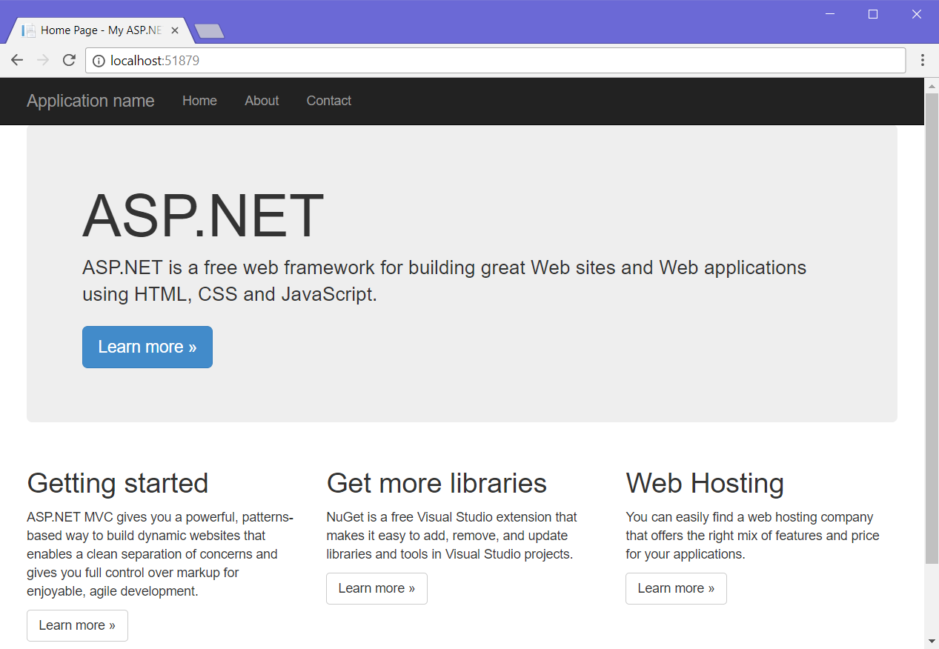

As we can see, we don’t really need that big panel about ASP.NET and those little sections at the bottom, so let’s remove them!

### Remove Unnecessary Views

Now that Visual Studio created the project, we need to remove some views we’re sure **won’t be needed**, like Contact.cshtmland About.cshtmlviews. Go into **solution explorer** and delete them, as well as the **Models** folder:

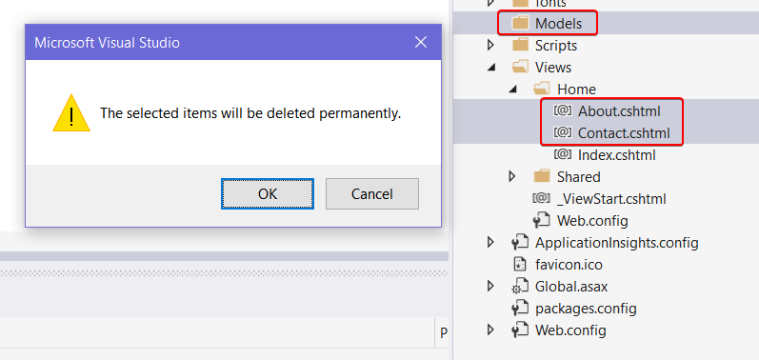

### Update Layout View

Now that we’ve deleted the unnecessary views, it’s time to go into the “Views/Shared/_Layout.cshtml” file and **edit** it a bit. For starters, let’s **update the header link**, which usually says “**Application Name**” to something nicer:

|  |
| --- |
|  |
|  |
|  |

Next, let’s remove those unneeded **menu items** in the **header**:

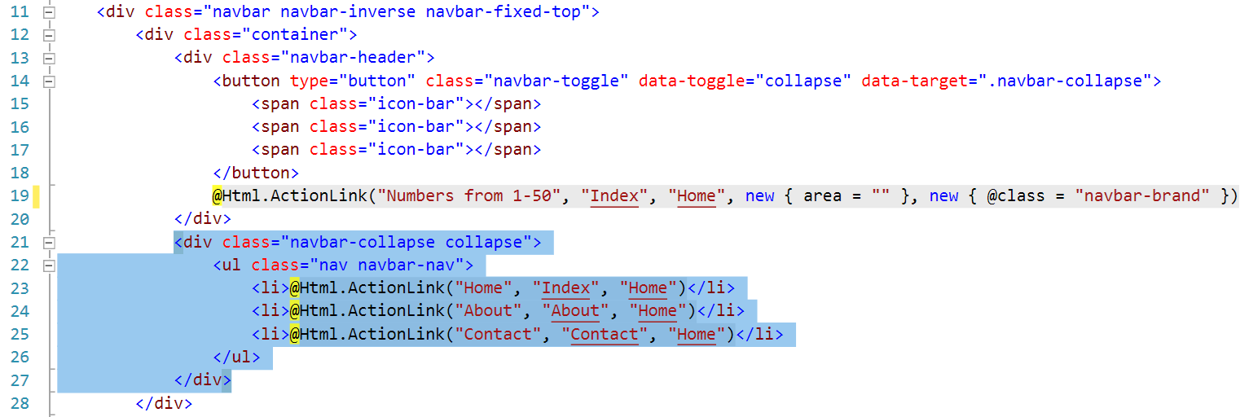

### Update Index View

Let’s go in “Views/Home/Index.cshtml” and remove everything unneeded, until all we’re left with is this:

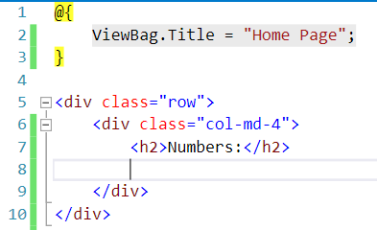

### Run the Project

Let’s see what we’ve got so far:

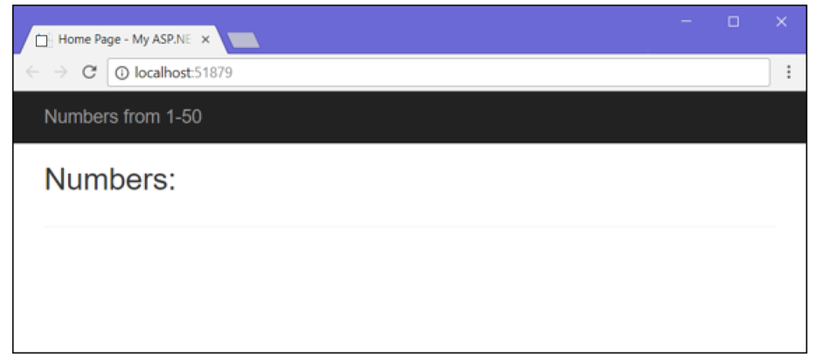

Looks good, but we need to print the numbers.

### Write List Logic

Let’s go back into the Index.cshtml file and create an **unordered list** with a simple **for-loop** inside it:

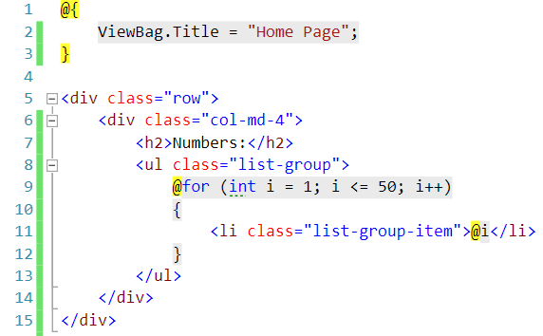

Refresh the page again and the result should show up:

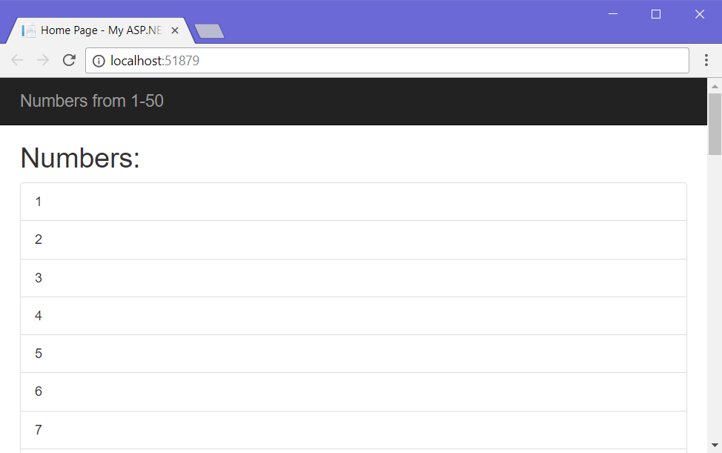

Looks like it works!